Cadorna, Joeffrey July 2, 2025
BSCS – 1 (CBM)
MP4: Shape Program Input
- Code:
def draw_rectangle(width, height, filled):
for h in range(height):
if filled:
print('*' * width)
else:
if h == 0 or h == height - 1:
print('*' * width)
else:
print('*' + ' ' * (width - 2) + '*')

def draw_left_triangle(length, filled):
for i in range(1, length + 1):
if filled:
print('*' * i)
else:
if i == 1 or i == length:
print('*' * i)
else:
print('*' + ' ' * (i - 2) + '*')

def draw_right_triangle(length, filled):
for i in range(1, length + 1):
if filled:
print(' ' * (length - i) + '*' * i)
else:
if i == 1 or i == length:
print(' ' * (length - i) + '*' * i)
else:
print(' ' * (length - i) + '*' + ' ' * (i - 2) + '*')

def draw_circle(radius, filled):
# Approximate circle in ASCII using midpoint circle algorithm idea
for y in range(-radius, radius + 1):
line = ""
for x in range(-radius, radius + 1):
dist = x**2 + y**2
if filled:
if dist <= radius**2:
line += '*'
else:
line += ' '
else:
# Outline only (distance close to radius squared)
if radius**2 - radius <= dist <= radius**2 + radius:
line += '*'
else:
line += ' '
print(line)

def draw_equilateral_triangle(base, filled):
height = (base + 1) // 2 # approximate height for ASCII art
for i in range(1, height + 1):
spaces = height - i
stars = 2 * i - 1
if filled:
print(' ' * spaces + '*' * stars)
else:
if i == 1:
print(' ' * spaces + '*')
elif i == height:
print('*' * (2 * height - 1))
else:
print(' ' * spaces + '*' + ' ' * (stars - 2) + '*')

def main():
shape = input("Enter shape to draw (rectangle, left triangle, right triangle, circle, equilateral triangle): ").strip().lower()
filled_input = input("Should the shape be filled? (yes/no): ").strip().lower()
filled = filled_input == 'yes'

if shape == "rectangle":
width = int(input("Enter width of rectangle: "))
height = int(input("Enter height of rectangle: "))
draw_rectangle(width, height, filled)

elif shape == "left triangle":
length = int(input("Enter length of left triangle: "))
draw_left_triangle(length, filled)

elif shape == "right triangle":
length = int(input("Enter length of right triangle: "))
draw_right_triangle(length, filled)

elif shape == "circle":
radius = int(input("Enter radius of circle: "))
draw_circle(radius, filled)

elif shape == "equilateral triangle":
base = int(input("Enter base length of equilateral triangle (odd number recommended): "))
draw_equilateral_triangle(base, filled)

else:
print("Unknown shape!")

if __name__ == "__main__":
main()
- Programiz Link: https://www.programiz.com/online-compiler/3oVoQa10QEnOE

- Narrative:

First of is the draw_rectangle(width, height, and filled), its purpose is to print a rectangle of given width and height in accordance to the user’s input value for the two variables (the width and the height). Where if filled is True, then it prints a full rectangle of * with all rows filled. If not, then it only prints the first and last rows fully (with the asterisk * repeated width times). Then for rows in between, the print * at the start and end, and spaces in between (in this case it is the width – 2 spaces.)
Second, draw_left_triangle(length, filled), which prints a left-aligned right-angled triangle. Where for each row i from 1 to length, it print i *, then if the user select filled, then it prints * continuously. If not, then it would only print * at the start and end of the row (firtst and last rows are solid).
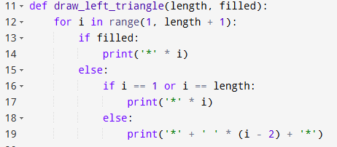
Third, the draw_right_triangle(length, filled), this outputs a right-aligned right-angled triangle. That for each row i from 1 to length, the print spaces first (length – i) to push starts to the right, that then prints the *. Filled would mean a continuous *, if not then it means the * are only at the edges and is/at the first and last rows of the shape.
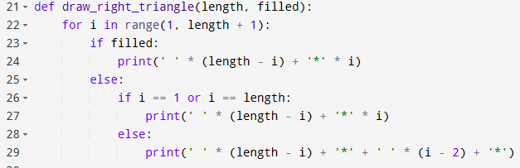
Fourth, the draw_circle(radius, filled), where its purpose is it prints an approximate circle using the ASCII art (essentially a graphic design/image/drawing with text characters), that loops over a grid of size that is determined by (2*radius +1) by (2*radius + 1), which calculates the squared distance from the center (0,0) for each point (x, y). If the user selects a filled circle/s, it prints * if the distance is less or equal to radius². If not, then it only prints * if the distance is close to the circumference or within a small margin around the radius², and the Else prints the space.
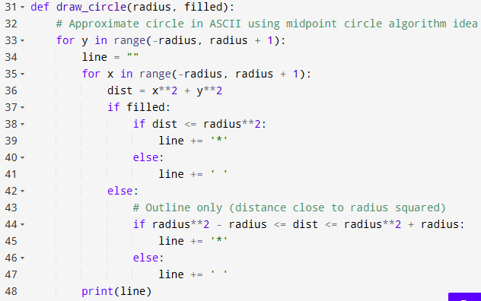
Fifth, the draw_equilateral_triangle(based, filled), which prints an equilateral triangle centered horizontally. Where it calculates the approximate height = (base + 1) // 2. I t then loops through row i from 1 to height. It proceeds to calculate the number of spaces to center the triangle and * for that specific row (2*i – 1). To reiterate, if the user selects filled, it prints a sold row of asterisk for the shape. If not, it prints the asterisk of the shape only at the edges of the triangle for middle rows, with the top row consisting of only a single star, and the bottom row being fully filled.
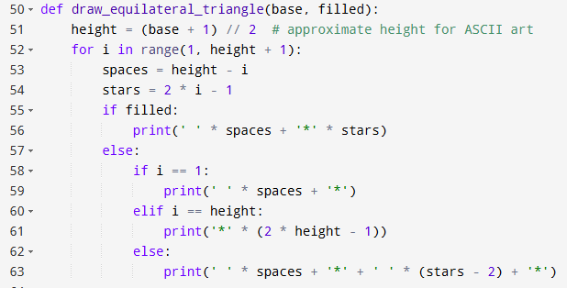
Sixth, the def main(). That prompts the user on the shape type of their choice, asks them on whether the shape should be filled or not, and in conjunction with that the dimensions of the shape (such as the width, height, length, radius, and base.) This calls the appropriate draw function with the parameters. Additionally, there is an error handling in the program, where if an unknown shape has been input by the user, it displays an error message and prompts the user to select the appropriate
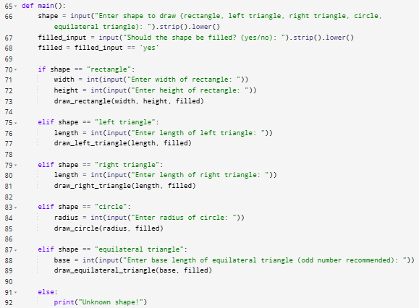
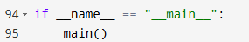
Lastly, here’s a few screenshots or snippets of the program’s output.
